

**EE5111 Selected Topics in Industrial Control**

**& Instrumentation**

**Project:** [**IoT project on Amazon AWS**](https://luminus.nus.edu.sg/modules/b36dc617-269d-44d6-bee4-c315bd16be68/quiz/0e5752c4-736a-4ec1-9b72-8f067712faac/attempt)

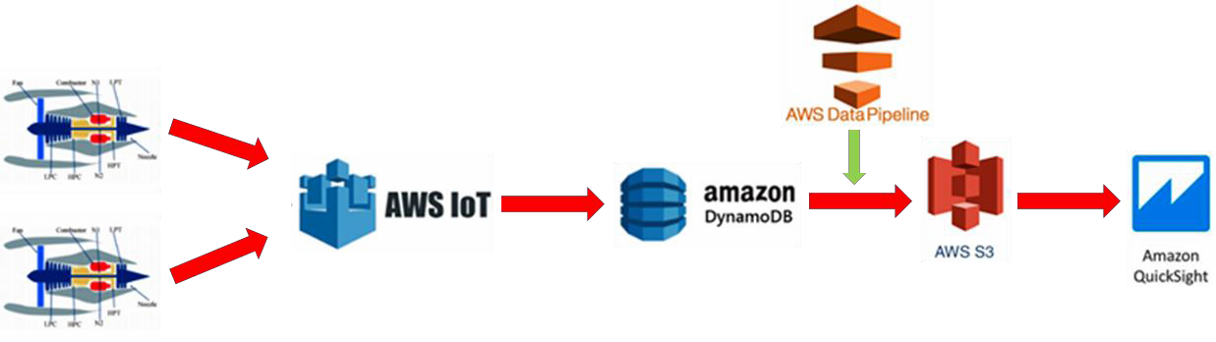

**Name: CHOONG SEAN FEN**

**Matriculation Number: A0103783H**

**Name: YANG ZHAO**

**Matriculation Number: A0103729H**

**DATE: Sep 20, 2019**

**Report Link:** [https://github.com/A0103729/EE5111_IoT-project-on-Amazon-AWS_A0103783H-](https://github.com/A0103729/EE5111_IoT-project-on-Amazon-AWS_A0103783H-A0103729H/commit/b0a90267a4df7a569610f3bd159a2c755d256591) [A0103729H/commit/b0a90267a4df7a569610f3bd159a2c755d256591](https://github.com/A0103729/EE5111_IoT-project-on-Amazon-AWS_A0103783H-A0103729H/commit/b0a90267a4df7a569610f3bd159a2c755d256591)

**Code Link:** https://github.com/A0103729/Q2-3-5-6-coding

Contents

1. Project Objective and Briefing 3
2. Simulation of Publish predefined engine data to AWS 4
   1. Publish one “thing” pre-defined engine data to AWS 4
      1. Thing, Certificate, Policy, Rules and DynamoDB table Set up 4
      2. Output in AWS & DynamoDB table. 6
      3. Simulation code 7
   2. Simulating the two "things" to run in parallel to publish data 8
      1. Thing, Rules and DynamoDB table Set up 8
      2. Output in AWS & DynamoDB table. 9
      3. Simulation code 10
   3. Visualize the two engines for all the sensors by querying the data from AWS DynamoDB 11
      1. Set Up S3 buckets. (S3 buckets name is ee5111awsbucket) 11
      2. Create Pipeline. (Pipeline name is ‘A0103783H_A0103729H_DataPepeline) 11
      3. Export data from DynamoDB to S3 through data pipeline 12
      4. Data successful export to S3 bucket and upload the data to Desktop 12
      5. Using QucikSight to visualize the data from desktop 12
3. Simulation of Singapore Graduates from University First Degree Courses By Type Of Course 14
4. Download data from gov website 14
5. Thing, Certificate, Policy, Rules and DynamoDB table Set up 14
6. Output in AWS & DynamoDB table. 15
7. Simulation code 16
8. Create Pipeline & Set Up 17
9. Download data from S3 Bucket to Desktop 18
10. Using QucikSight to visualize the data from desktop 18
11. Simulation of real-time data of Singapore Relative Humidity - Monthly Absolute Extreme Minimum 20 i. Thing, Certificate, Policy, Rules and DynamoDB table Set up 20
12. Output in AWS & DynamoDB table. 21
13. Simulation code 21
14. Create Pipeline & Set Up 23
15. Download data from S3 Bucket 24
16. Using QucikSight to visualize the data from desktop 25
17. **Project Objective and Briefing**

#### PART I:

##### We simulated one and two small IoT things record and push data from two jet engines and visualizing the data through Amazon quick sight.



#### PART II:

##### We simulated Singapore University Graduates Raw Data record and push from data.gov.sg website and visualizing the data through Amazon quick sight. [https://data.gov.sg/dataset/graduates-from-university-first-degree-courses-by-type-of-](https://data.gov.sg/dataset/graduates-from-university-first-degree-courses-by-type-of-course) [course](https://data.gov.sg/dataset/graduates-from-university-first-degree-courses-by-type-of-course)

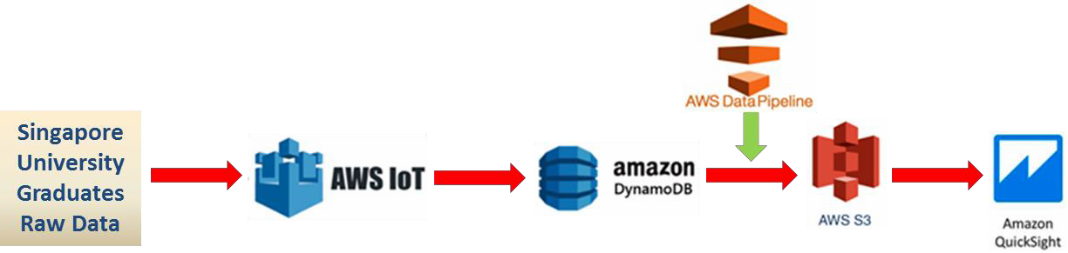

#### PART III:

##### We simulated real-time data from embedded systems with AWS Cloud platform and visualize the data through Amazon quick sight.

**Real-time data name:** Singapore Relative Humidity - Monthly Absolute Extreme Minimum

**Real-time data API:** [https://data.gov.sg/api/action/datastore_search?resource_id=585c24a5-76cd-4c48-9341-](https://data.gov.sg/api/action/datastore_search?resource_id=585c24a5-76cd-4c48-9341-9223de5adc1d&amp;q=99999) [9223de5adc1d&q=99999](https://data.gov.sg/api/action/datastore_search?resource_id=585c24a5-76cd-4c48-9341-9223de5adc1d&amp;q=99999)

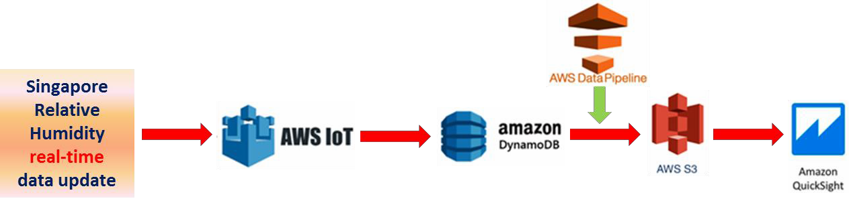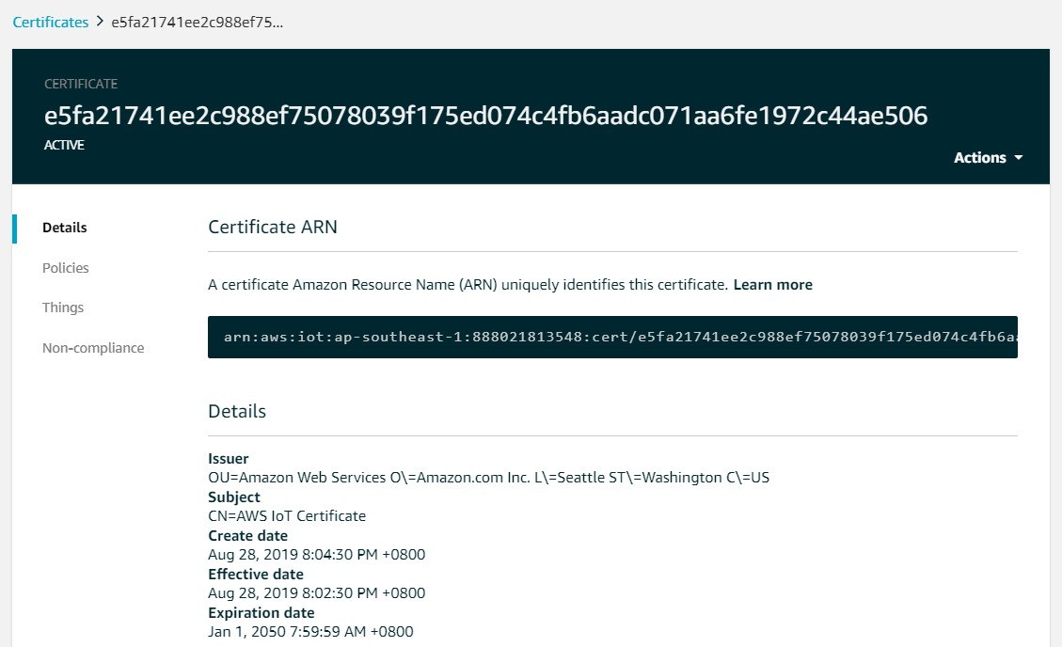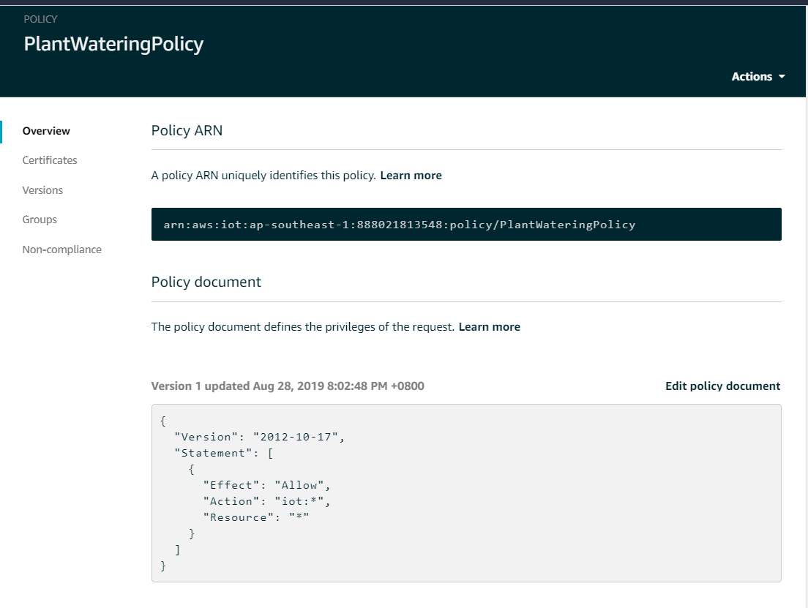

# Simulation of Publish predefined engine data to AWS

## Publish one “thing” pre-defined engine data to AWS.

### Thing, Certificate, Policy, Rules and DynamoDB table Set up.

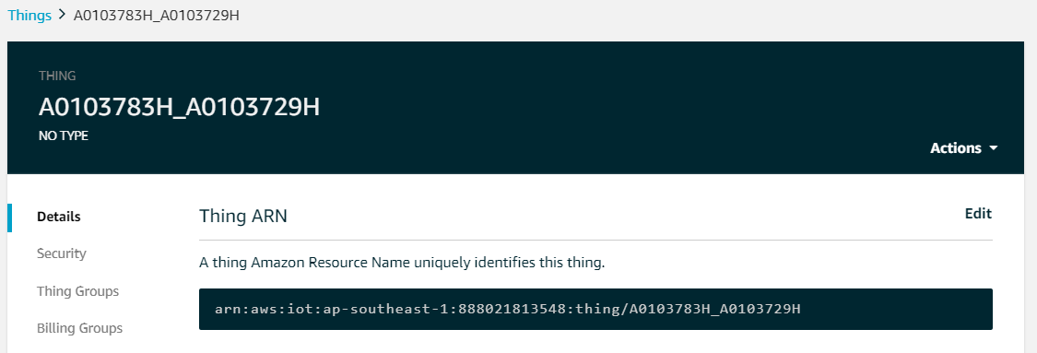

Choong Sean Fen & Yang Zhao National University of Singapore A0103783H&A0103729H

A0103783H_A0103729H_Rule

ENABL£D

Actions .....

Overview Description

Tags No description

Rule qu ery statement

The source of the messages you want to process withthis rute.

Edit

Edit

|  |  |  |  |  |  |  |  |  |  |  |
| --- | --- | --- | --- | --- | --- | --- | --- | --- | --- | --- |
| <.,f[f(l | | |  | '>tdtP |  | rPportPd"' | |  | FROM |  |
|  | ' $ | cH•I'>/t h l np,,'>/ A010 *18* HI | | | | |  | A01@ /.?c;Hj-,hddow/updclt P/ d< < t-'pt t->d | | |

Using SQL version 2016-03-23

Actions

Actions are what happens when a ru le is triggered. Lea rn more

•

Split messa ge into multiple colu m ns of a Dyna ...

A0103783H_A0103729H_D8Table

Edit

Add action

Error action

A0103783H_A0103729 H DBTable Close

Overv iew

Recent alerts

Items Metrics Alarms Capacity Indexes Global Tables Backups Triggers Access control

Tags

No CloudWatch alarms have been tnggered for th1s table

Stream details

Stream enabled No

View type

Latest stream ARN

Manage Stream

able details

Table name Primary part tion key Primary sort key

Point-in-time recovery

Encryption Type KMS Master Key ARN Time to live attribute

Table status Creation date

Read/write capacity mode

A0103783H_A01037 29H_DBTable

id (Stnng) timestamp (Stnng) DISABLED Enable

DEFAULT Manage Encryption

NolApplicable DISABLED Manage TTL

Act1ve

Seplember 1,2019 al9 47 57 AM UTC+8

Provisioned

SI Page

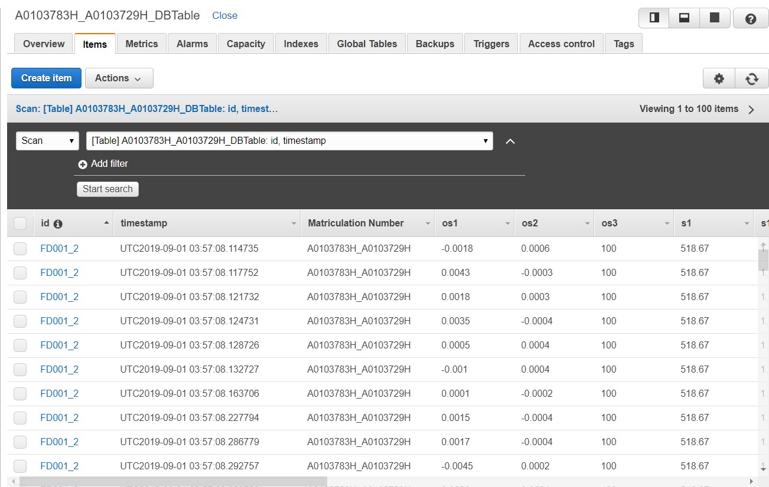

### Output in AWS & DynamoDB table.

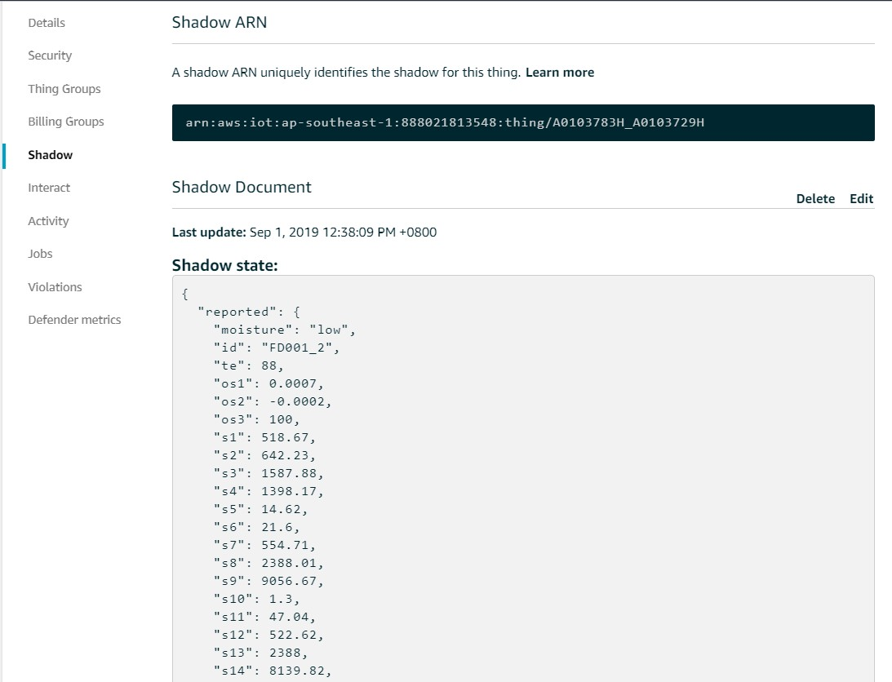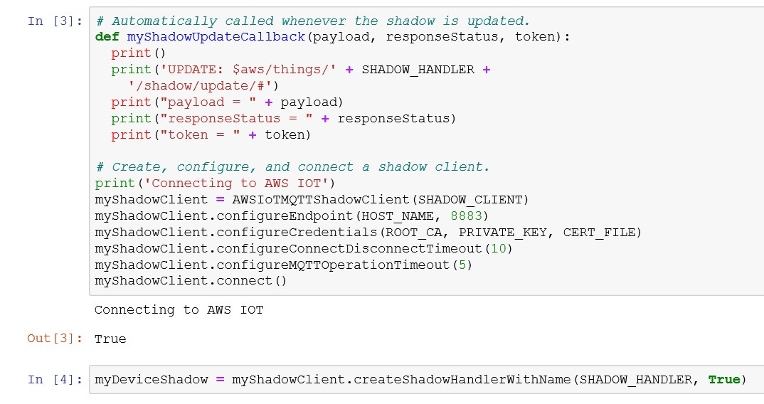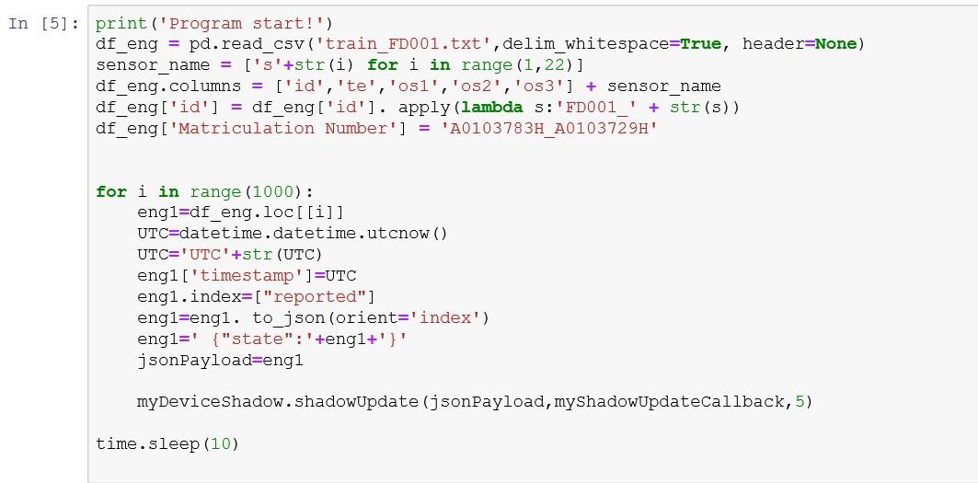

### Simulation code

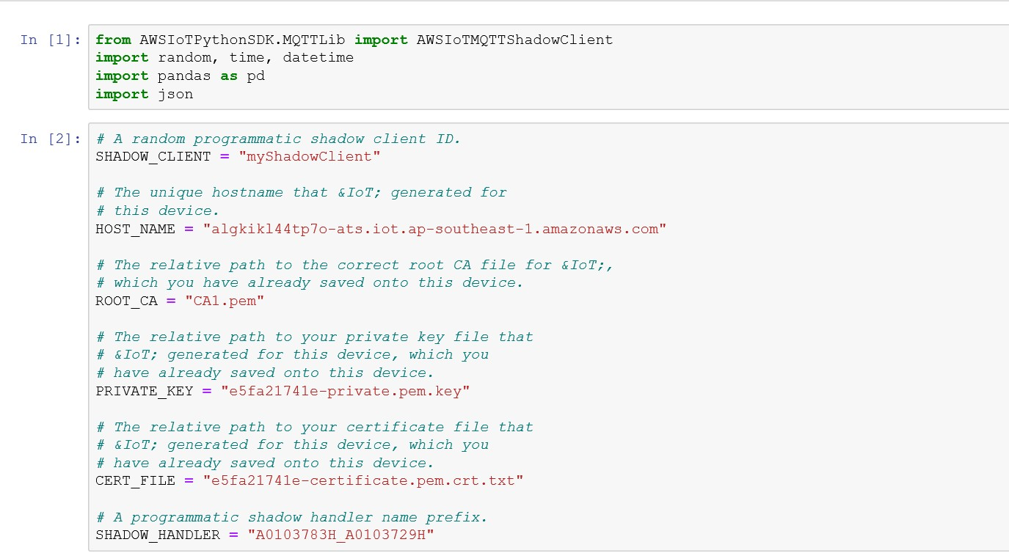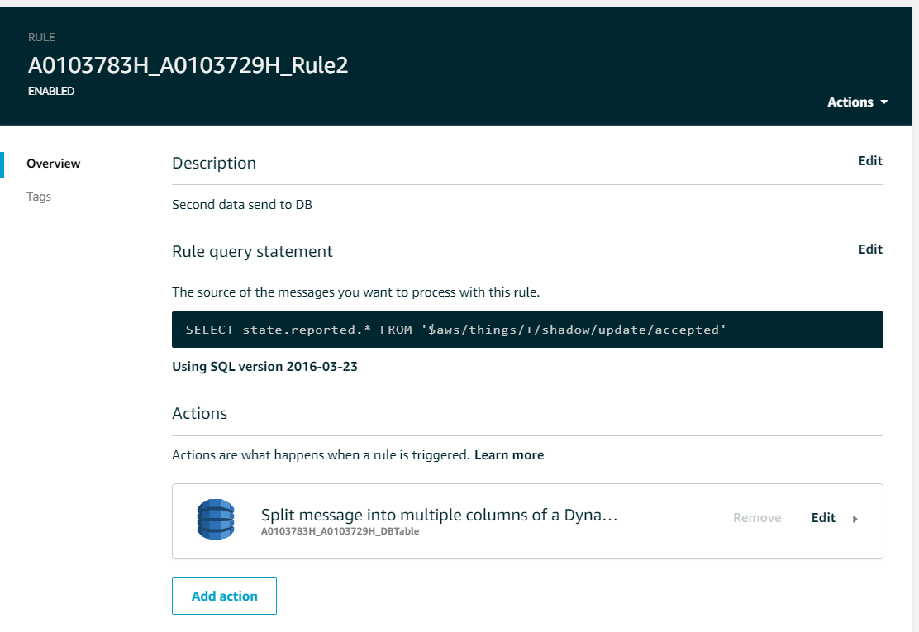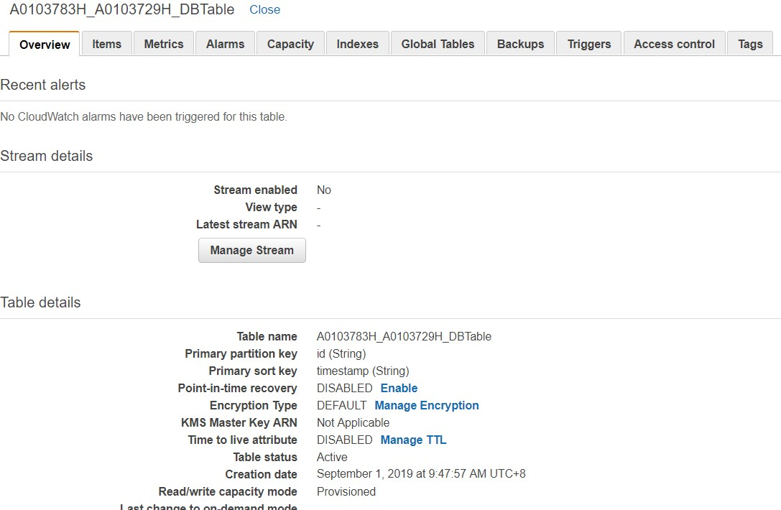

## Simulating the two "things" to run in parallel to publish data.

### Thing, Rules and DynamoDB table Set up.

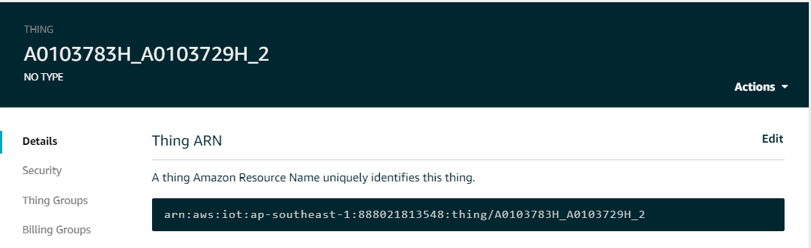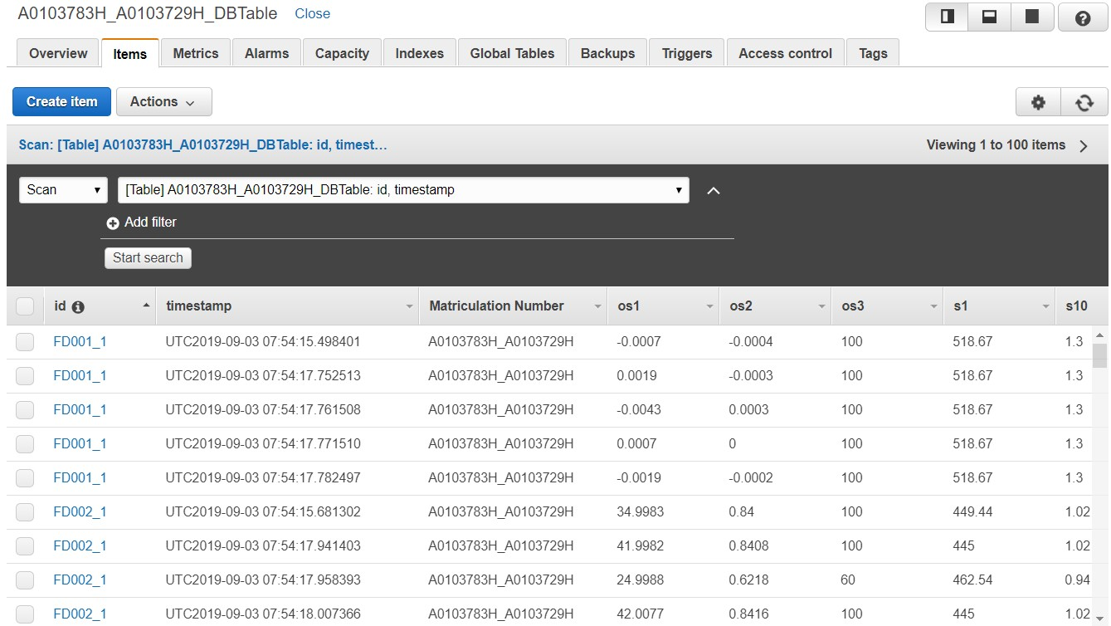

### Output in AWS & DynamoDB table.

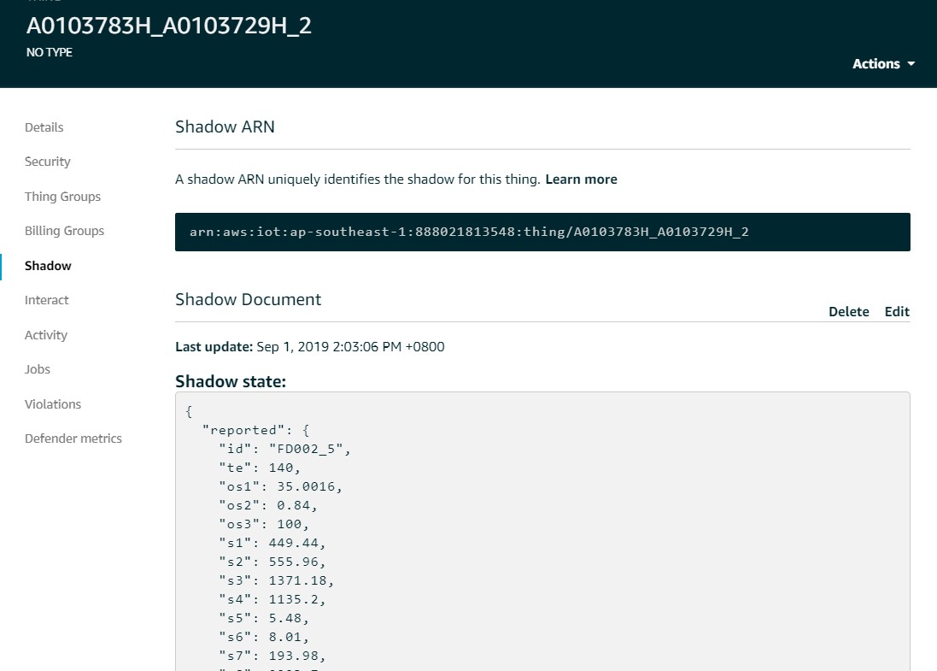

|  |  |  |
| --- | --- | --- |
|  | |  |
|  | |  |
|  | |  |
|  |  |
|  | |

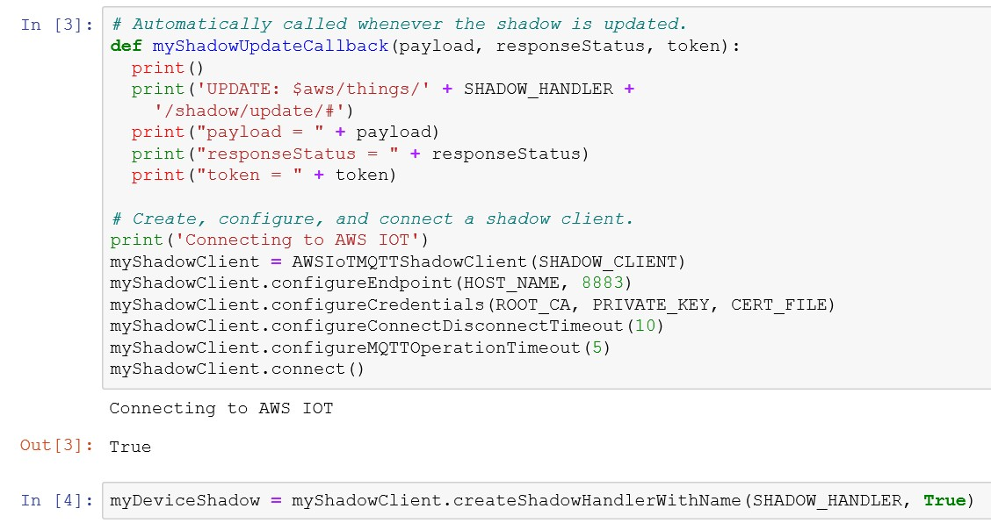

### Simulation code

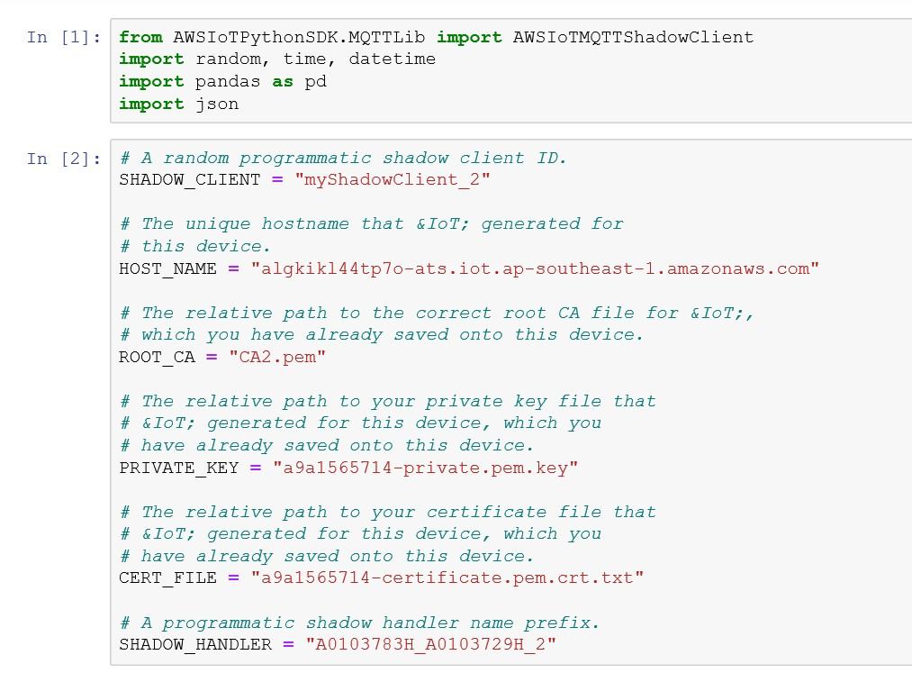

## Visualize the two engines for all the sensors by querying the data from AWS DynamoDB

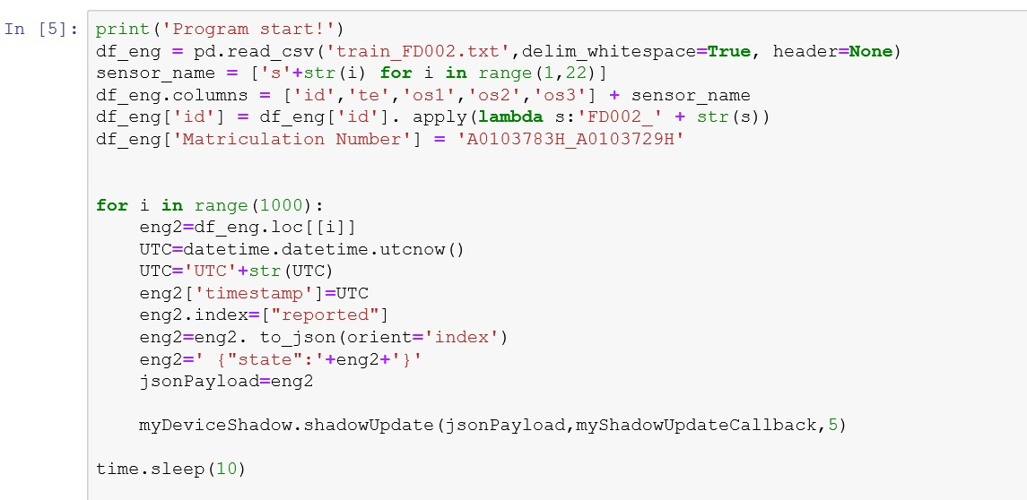

##### Export data from DynamoDB to ‘S3’ through ‘Data Pipeline’

##### Upload the two engines data from S3 and visualization the data by QuickSight.

### Set Up S3 buckets. (S3 buckets name is ee5111awsbucket)

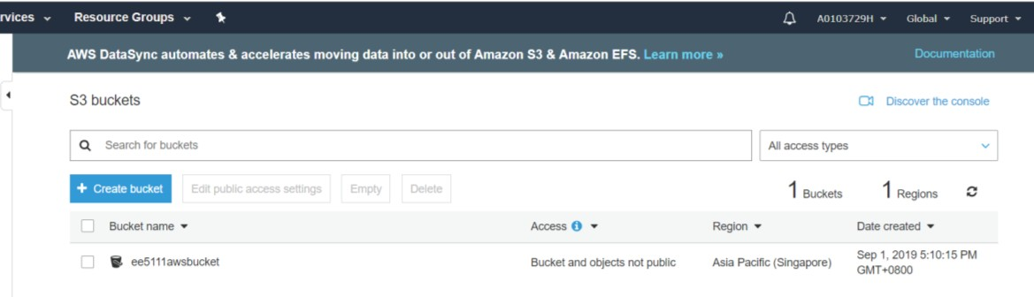

### Create Pipeline. (Pipeline name is ‘A0103783H_A0103729H_DataPepeline)

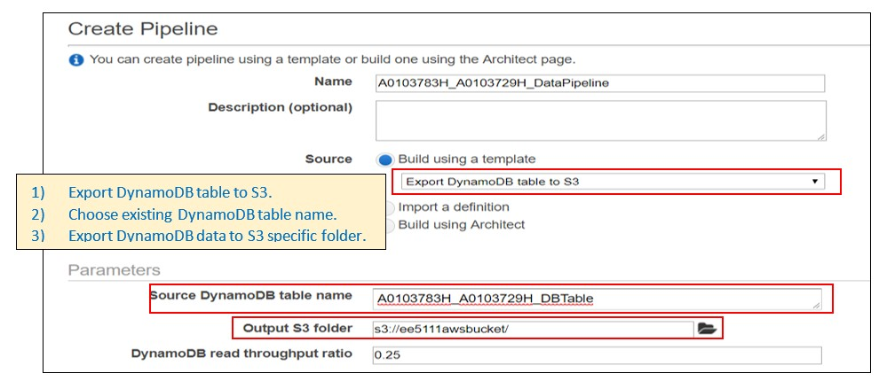

### Export data from DynamoDB to S3 through data pipeline

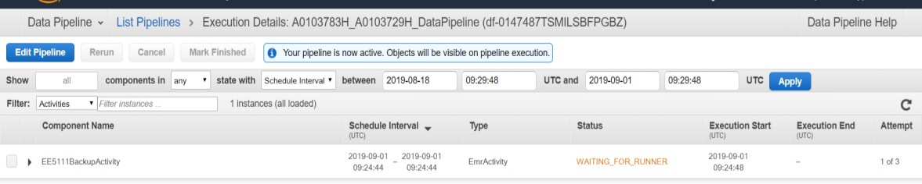

### Data successful export to S3 bucket and upload the data to Desktop.

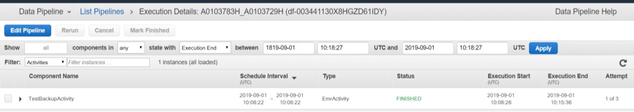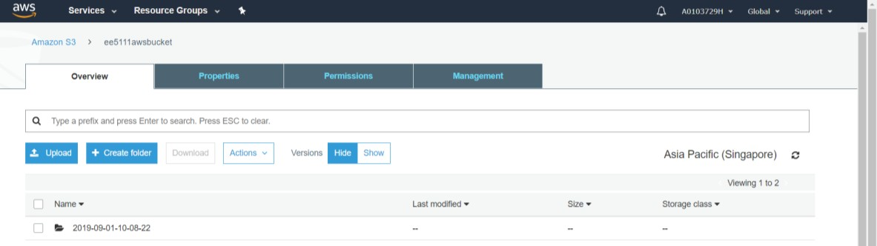

### Using QucikSight to visualize the data from desktop.

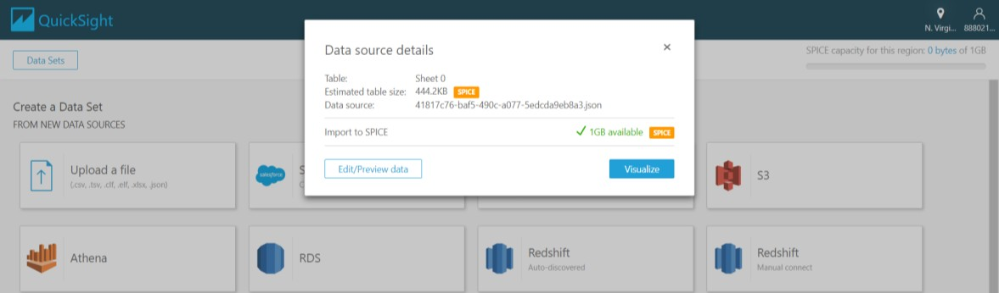

Choong Sean Fen & Yang Zhao National University of Singapore A0103783H&A0103729H

Count of Records by Os1.n

10

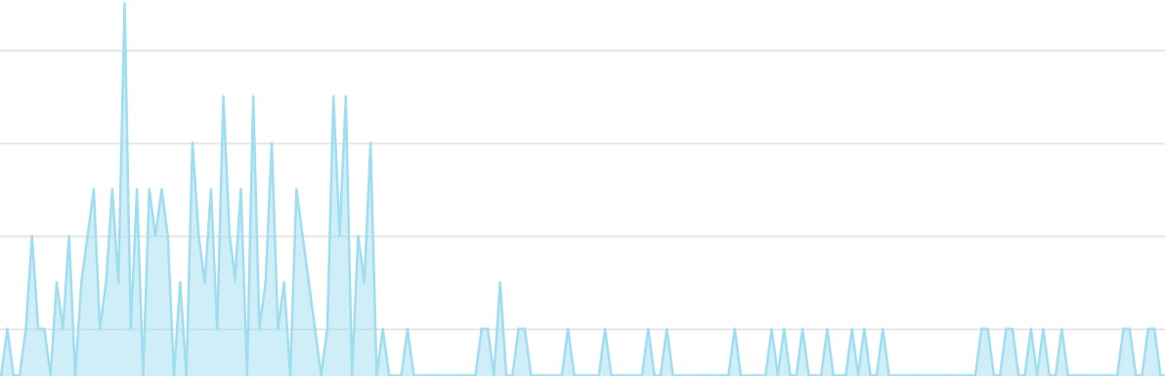

oL---------------------------------------------------------------------------------------------

# ! ! {9:_ ¥

os1.n

Sum of Os1.n, Sum ofTe.n, Sum of Os2.n, Sum of Os3.n, Sum of S1.n,Sum of S10.n, Sum of S11.n,and Sum of S12.n by Te.n

2.5K

te.n



Leqend

osl.n

r" te.n os2.n os3.n

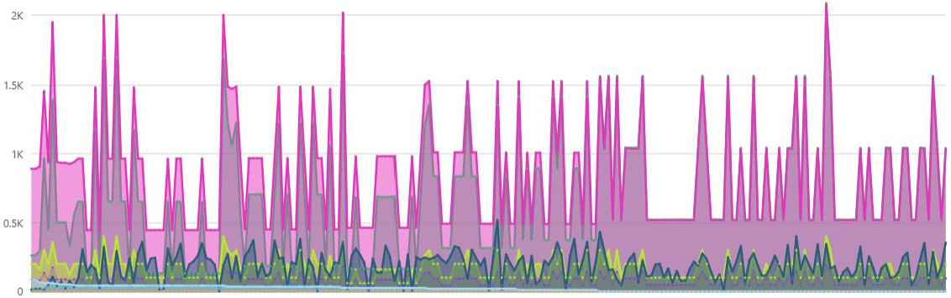

,.,sl.n

,.,s10.n

,.,s11.n

,.,s12.n

**os3.n s1.n os1.n os2.n s10.n s11.n s1Z.n s13.n s14.n s1S.n s16.n s17.n s18.n**

**s9.n**

>9.n

100 968.11 35_0014 0.8402 2.32 89.21 705.4 4,775_72

16,20078 17.7563 0.05 727 4,611

17,408.4

17.4084

100

60

100

100

60

60

100

100

100

445 41.9982 0.8408 1.02 42.2

462.54 24.9988 0.6218 0.94 36.69

518.67 0.0002 -0.0005 1.3 47.11

1,454.86 62.0075 1.5424 3.4 133.48

462.54 25.0005 0.6203 0.94 36.89

462.54 25.0045 0.6205 0.94 36.78

890 84.0114 1.6809 2.04 84.24

491.19 20.002 0.7002 1.08 44.27

890 84.0005 1.682 2.04 84.09

130.42 2.387.66

164.22 2.028.03

522.85 2.388.02

967.99 7,163.64

164.31 2.028

164.27 2.028.01

261.01 4,775.85

315.11 2.387.99

261.5 4,775.72

8,072.3 9.3774 0.02 330 2.212

7,864.87 10.8941 0.02 309 1,915

8,148.42 8.399 0.03 393 2,388

24,282.01 26.9234 0.07 1,082 6,924

7,861.23 10.8963 0.02 309 1,915

7,868.87 10.8912 0.02 306 1,915

16,1622 18.7092 0.04 659 4,424

8,049.26 92369 0.02 365 2.324

16,155.94 18.7161 0.04 661 4,424

8,303.96

8,001.42

9,06821

26,093.35

7,993.23

7,996.1

16,628.58

8,709.12

16,639.9

8,303.96

8,001.42

9,068.21

26,093.35

7,993.23

7,996.1

16,628.58

8,709.12

16,639.9

"" 10 fi M



1M% :>.O:>R

*7.R77* ')<; 10JUl14

"'" 1,<nr;

R,010_fi}

R,010.fl;>

100 10

100 11

100 12

100 13

445 42.0011 0.84

934.05 52.0053 1.09

518.67 0.0015 0.001

491.19 20.0003 0.7

1.02

2.28

1.3

1.08

42.02

87.36

47.34

44.43

130.5 2.387.62

501.91 4,775.7

521.29 2.388.16

314.77 2.388.04

8,069.11 9.3957

16,204.17 18.0274

8,121.09 8.3892

8,048.52 9.1968

0.02

0.05

O.Q3

0.02

329

699

393

365

2.212

4,531

2,388

2,324

8,302.31

17,086.5

9,038.84

8,710.39

8,302.31

17,086.5

9,038.84

8,710.39

13 I Page

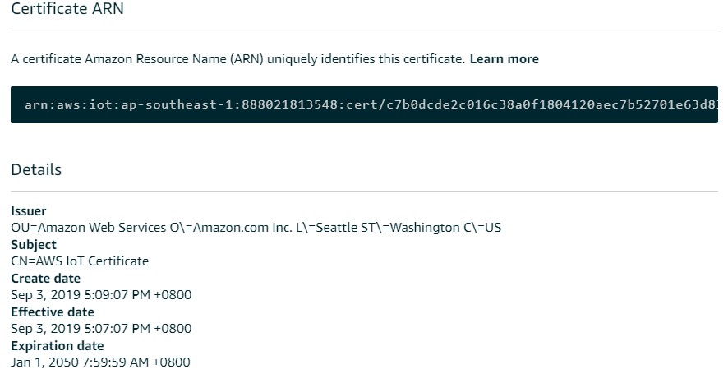

# Simulation of Singapore Graduates from University First Degree Courses By Type Of Course

### Download data from gov website

##### From [https://data.gov.sg/dataset/graduates-from-university-first-degree-](https://data.gov.sg/dataset/graduates-from-university-first-degree-courses-by-type-of-course) [courses-by-type-of-course](https://data.gov.sg/dataset/graduates-from-university-first-degree-courses-by-type-of-course) website.

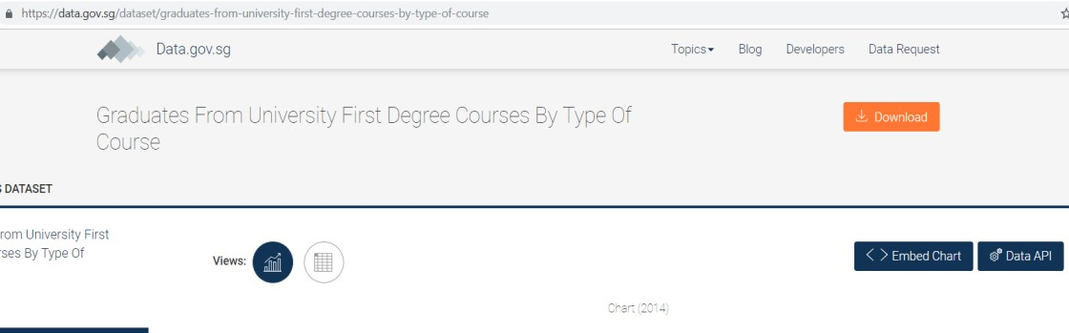

### Thing, Certificate, Policy, Rules and DynamoDB table Set up.

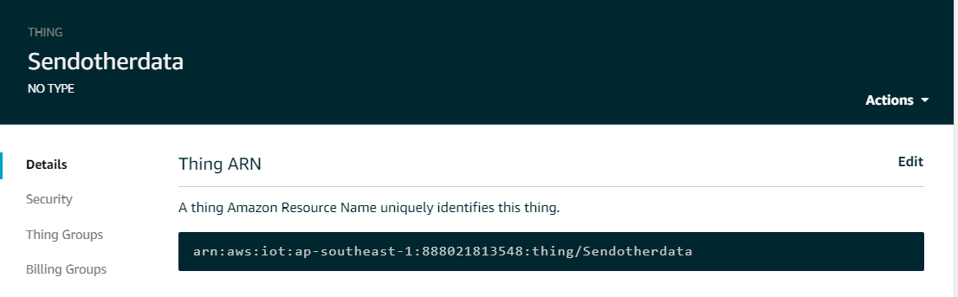

### Output in AWS & DynamoDB table.

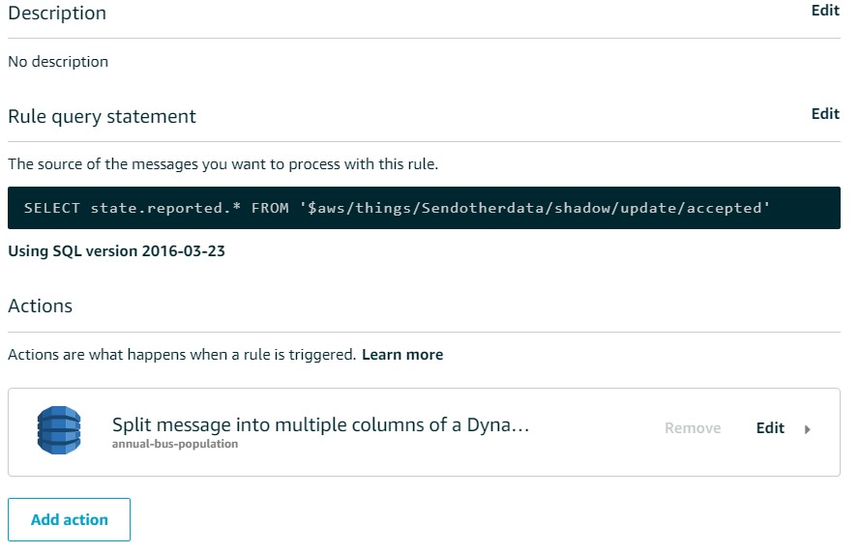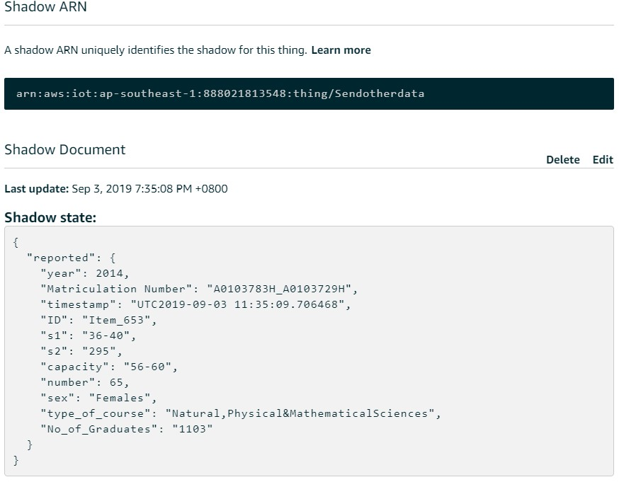

### Simulation code

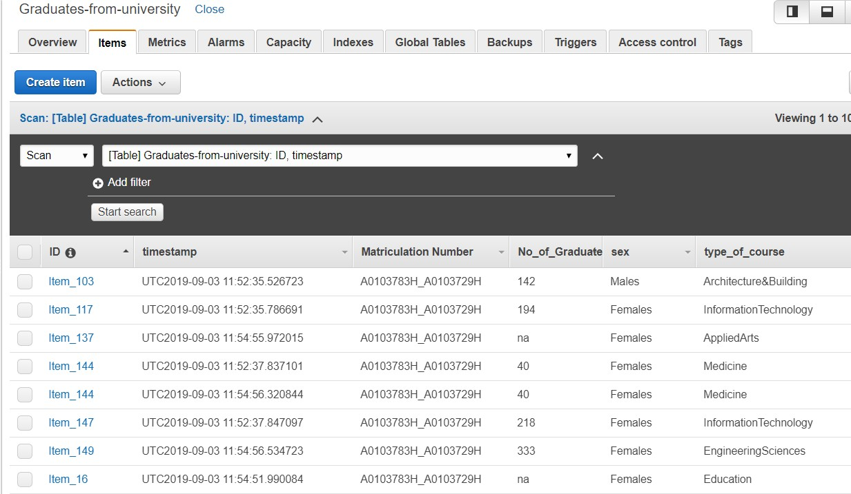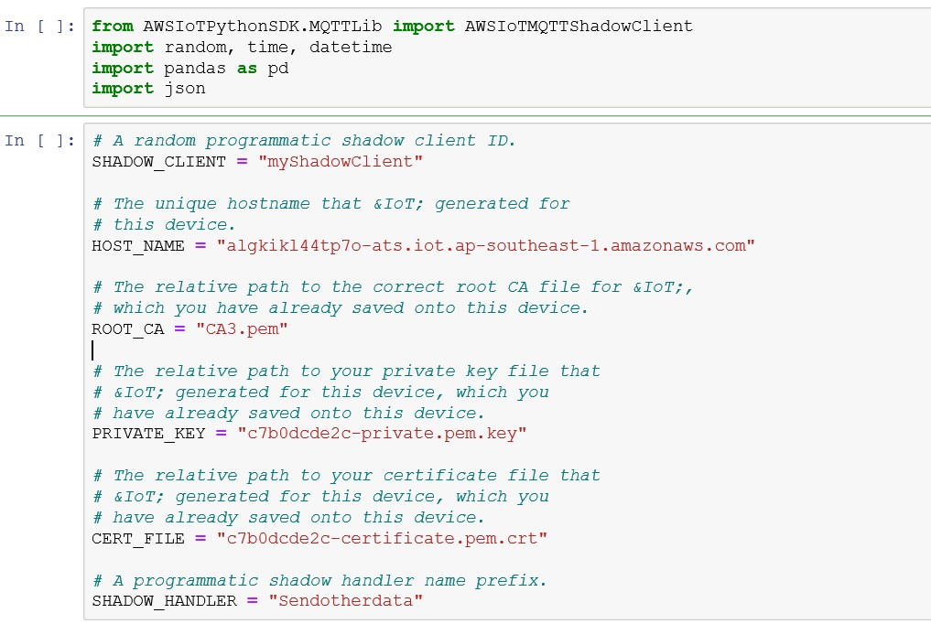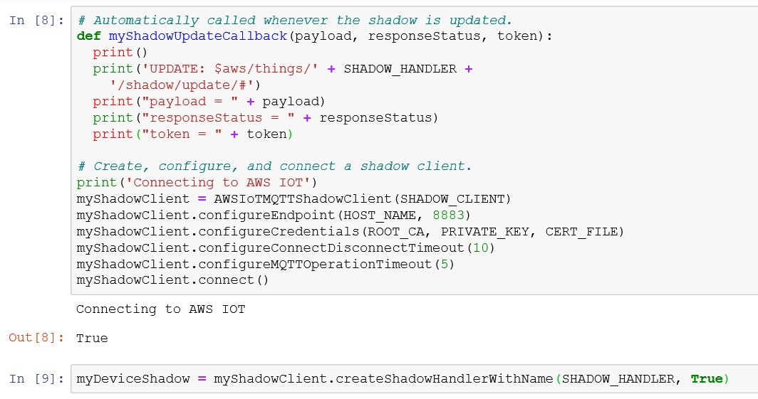

### Create Pipeline & Set Up

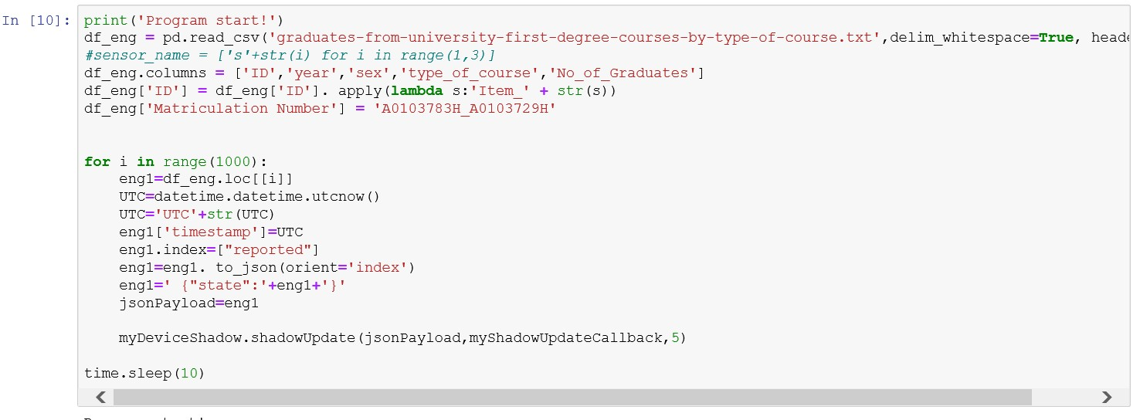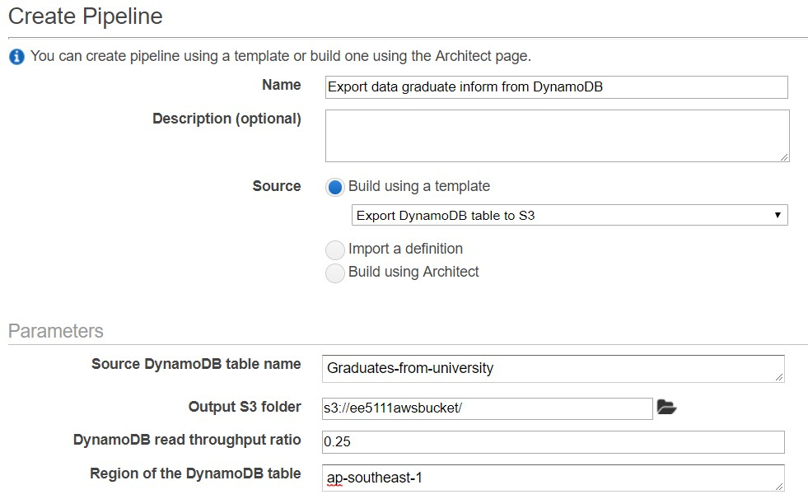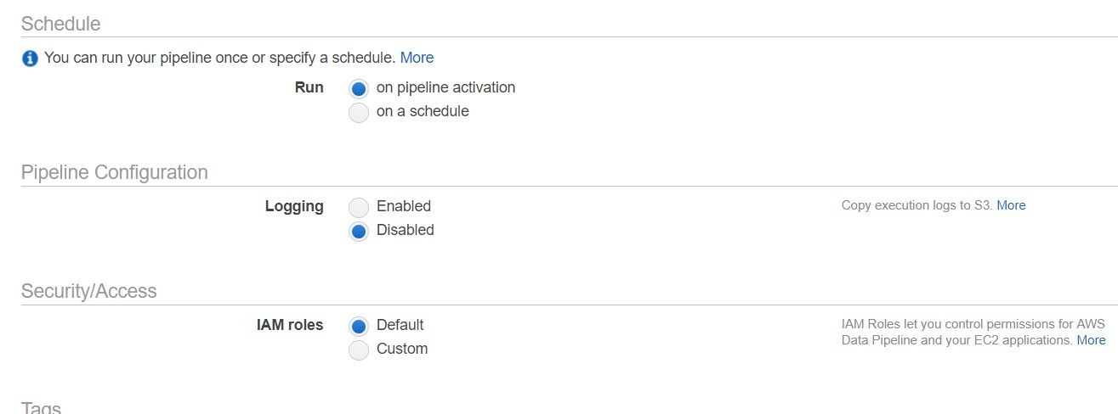

|  |  |  |
| --- | --- | --- |
|  | | |
|  |  |  |

### Download data from S3 Bucket to Desktop

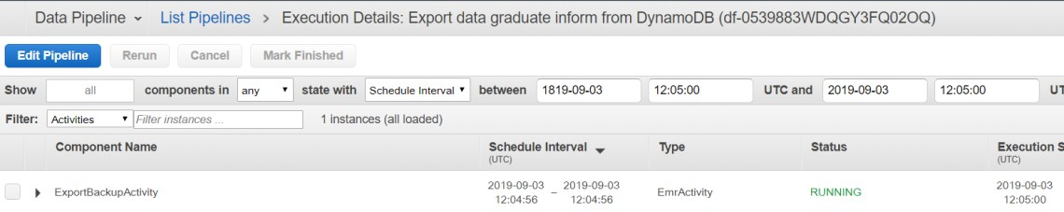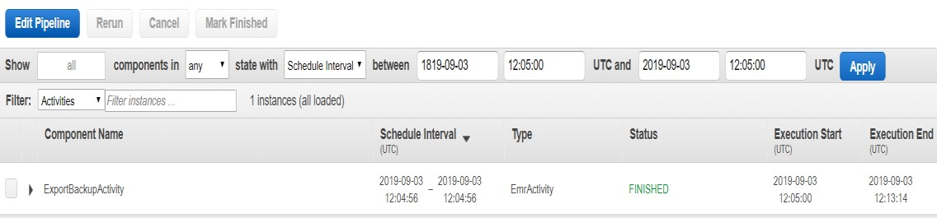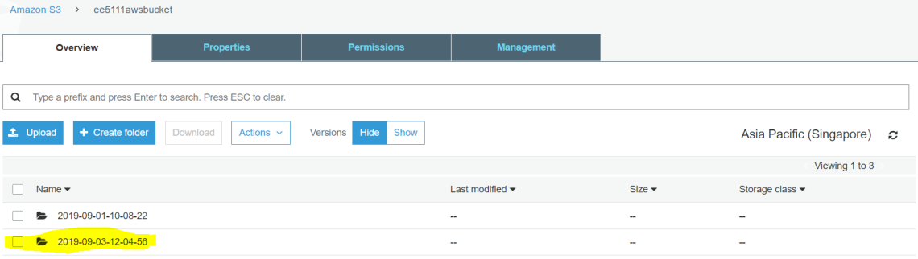

### Using QucikSight to visualize the data from desktop.

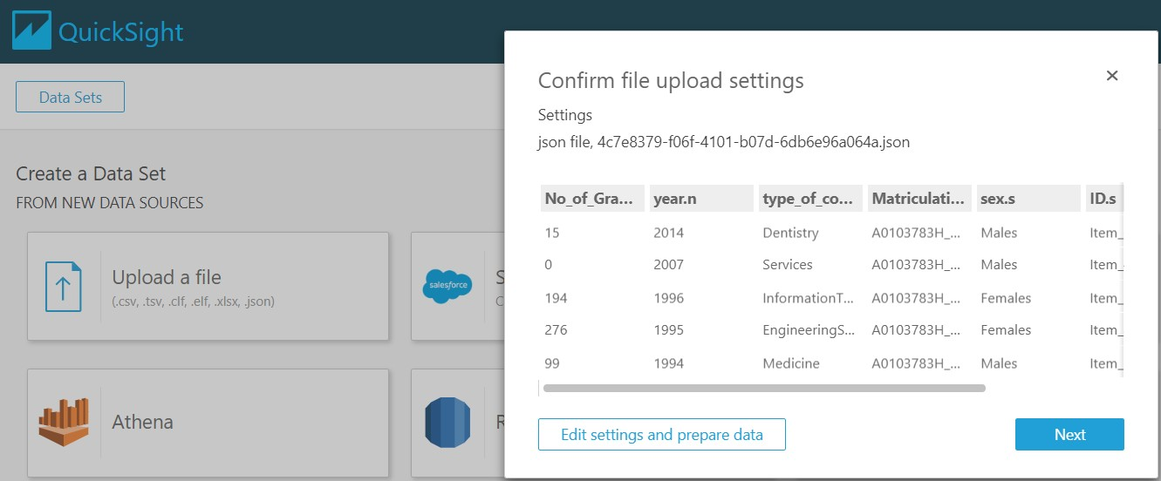

Sum of No_of_graduates.s and Sum of Type_of_course.s

No_of_graduates.s by

EngineeringSciences ---



leqend

1INo_of_Gra...

Humanities&SodaiSciences

-

Naturai,Physicai&MathematicaiSciences

Busmess&Adm•mstrcltlon

•

Accountancy



•

InformatiOnTechnology

Atch1tecture&Bulld •ng

Educat1on I

L•w I

Medicine I

MassCommunication I

Field wells Group/Color 0type_of_course.s Value # No_of_Graduates.s (Sum)

Sum of No_of_graduates.s by Type_of_course.s v

Type of co...

Engineerin...

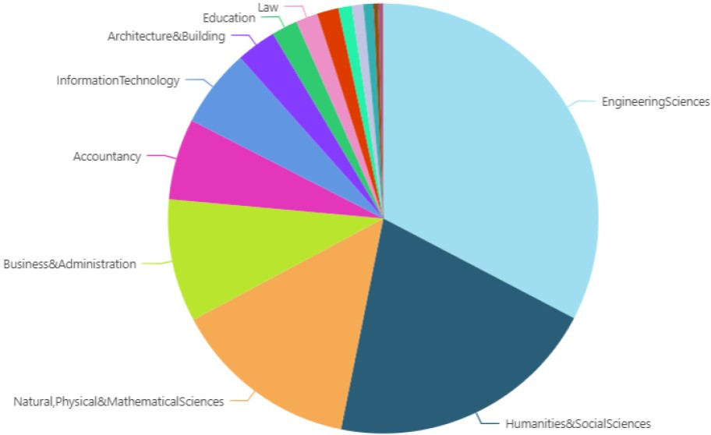

•Humanitie...

•Naturai,Ph...

Business&...

•Accounta ...

•lnformatio...

•Arch1tectu...

•Education

•law

•Medicine

•MassCom...

HealthScie...

•AppliedArts

•Services

•Dentistry

Group By: type_of_course.s v

!!,. Size: No_of_Graduates.s (Sum) v

Sum of No_of_graduates.s by Sex.s and Type_of_course.s

No



Type of cou...

###### >

E

::>

.,;

::>

--.zs

lOOK

7SK

Accountancy

**ol** AppliedArts

**.1**Architecture...

Business&A...

**.1**Dentistry

**.1** Education

•I Engineering

" SOK

a'

o'

z:

**.1** HealthScien...

**.1** Humanities...

ZSK

Males Females

*z* Group By: sex.s '-"

**•I** Information...

**•I** Law

MassComm ...

•I Medicine

**.1**Naturai,Phys...

19 I Page

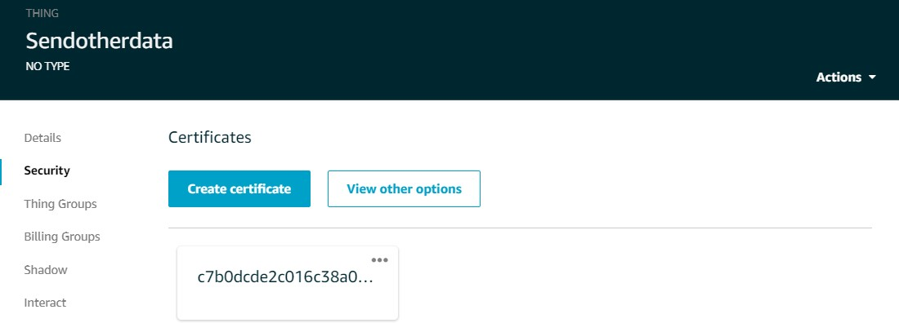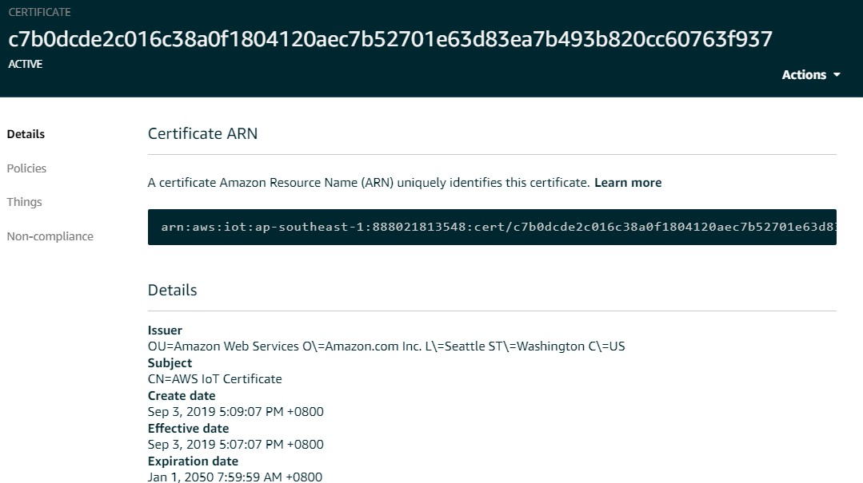

1. Simulation of real-time data of Singapore Relative Humidity - Monthly Absolute Extreme Minimum

i. Thing, Certificate, Policy, Rules and DynamoDB table Set up.

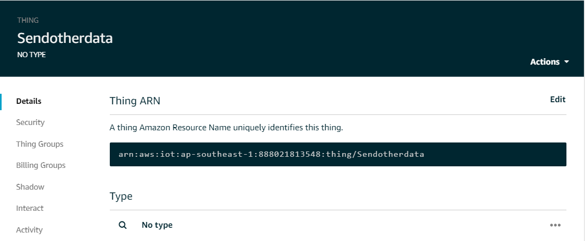

### ii. Output in AWS & DynamoDB table.

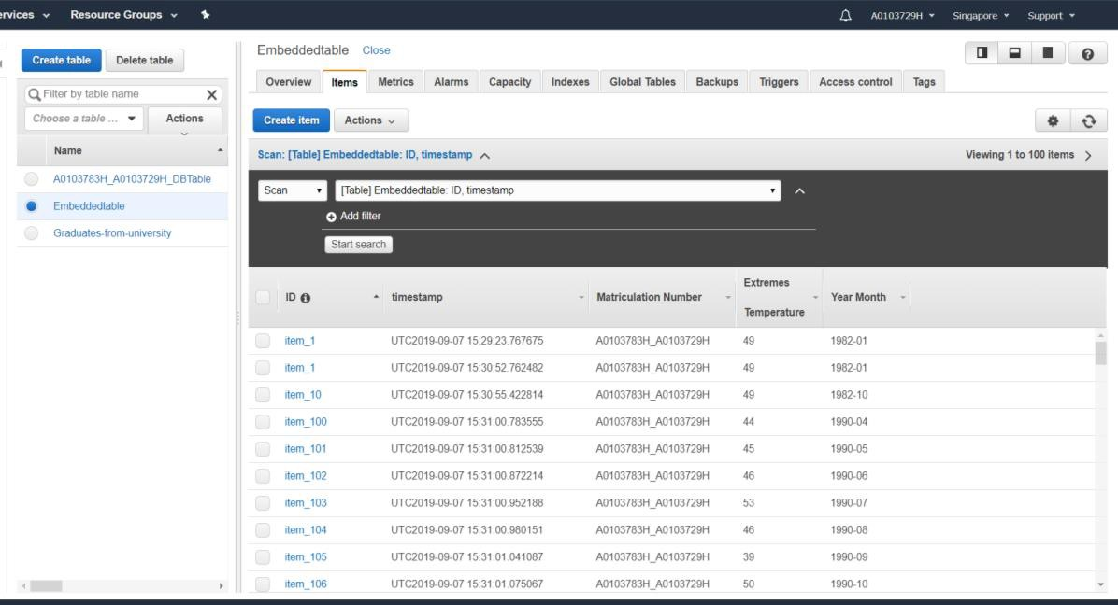

### Simulation code

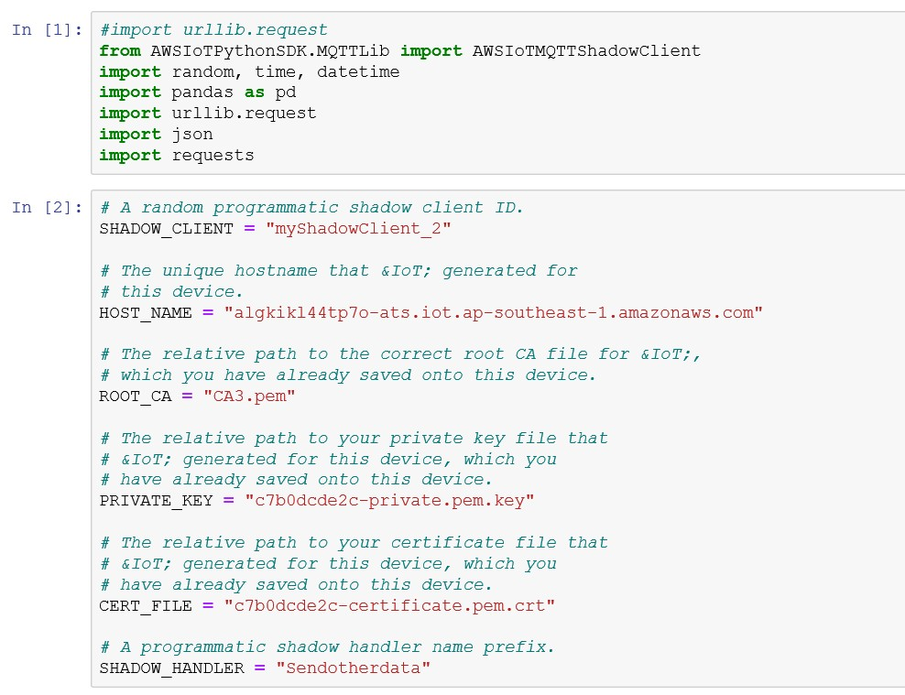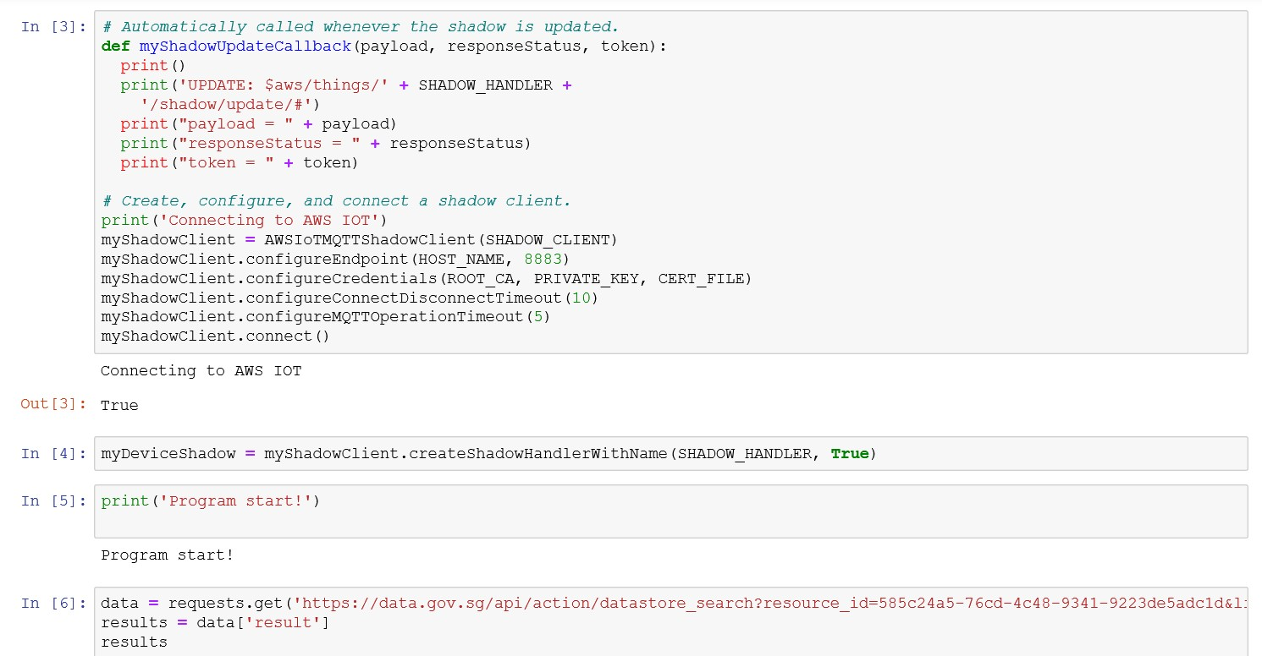

###### Get real time data from gov website

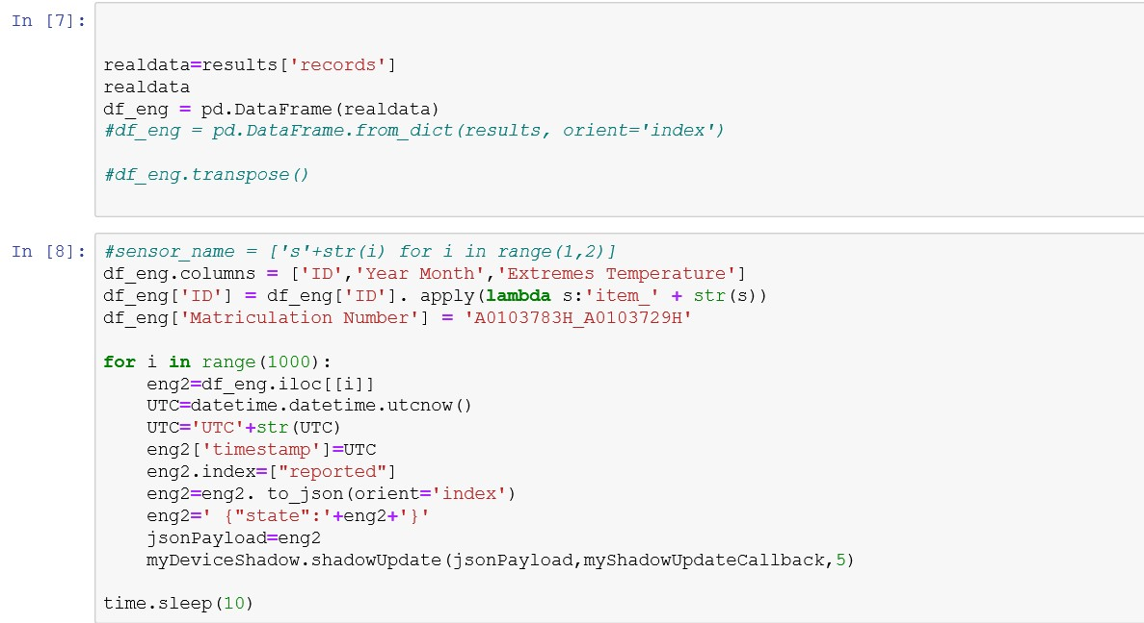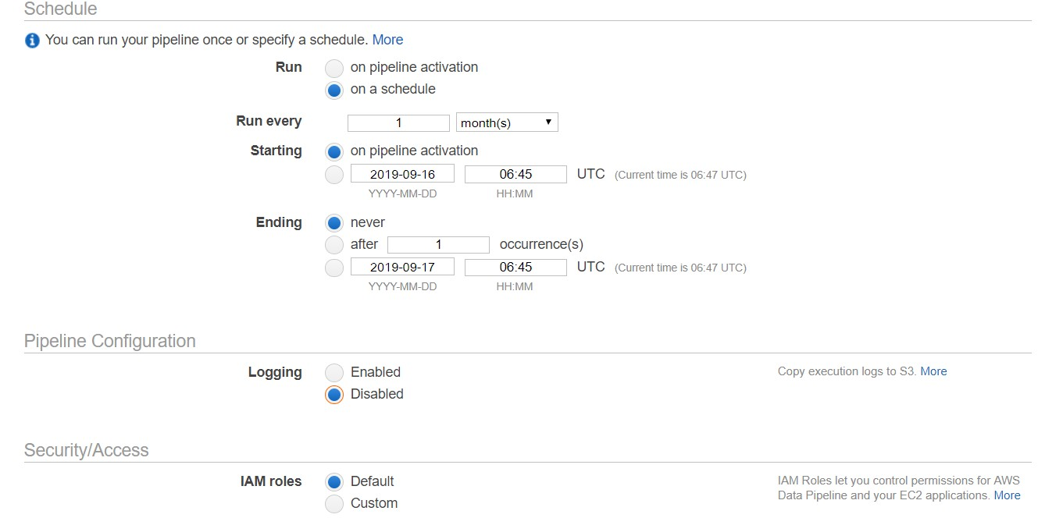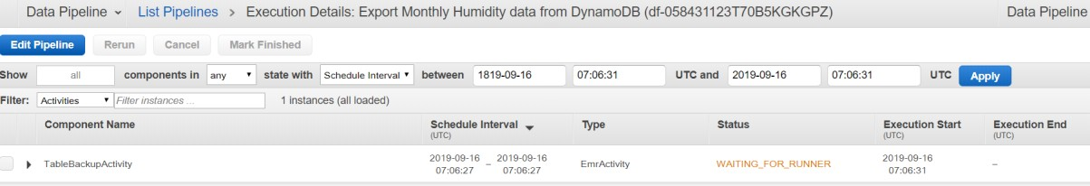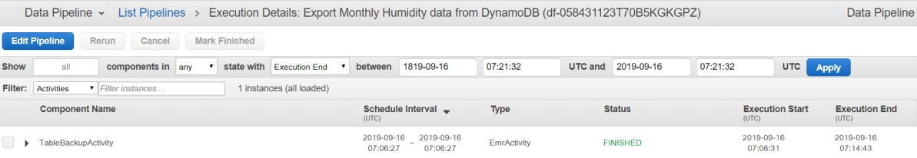

### Create Pipeline & Set Up

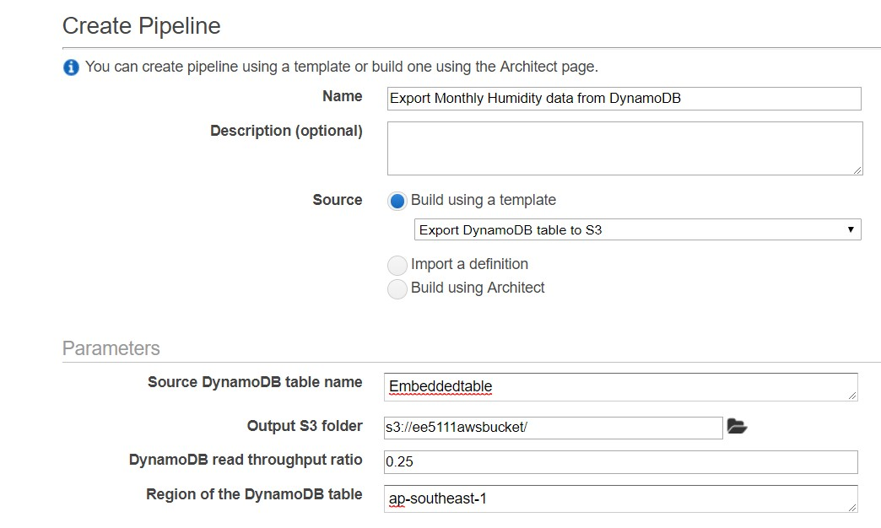

Auto collect data

|  |  |  |
| --- | --- | --- |
|  | | |
|  |  |  |

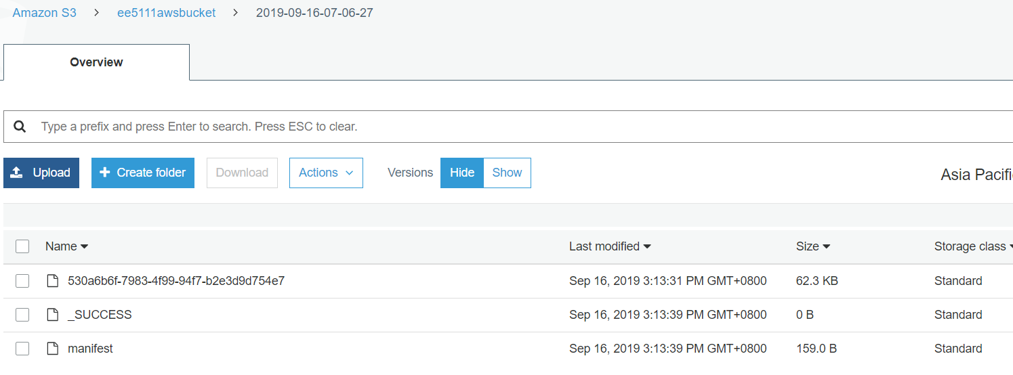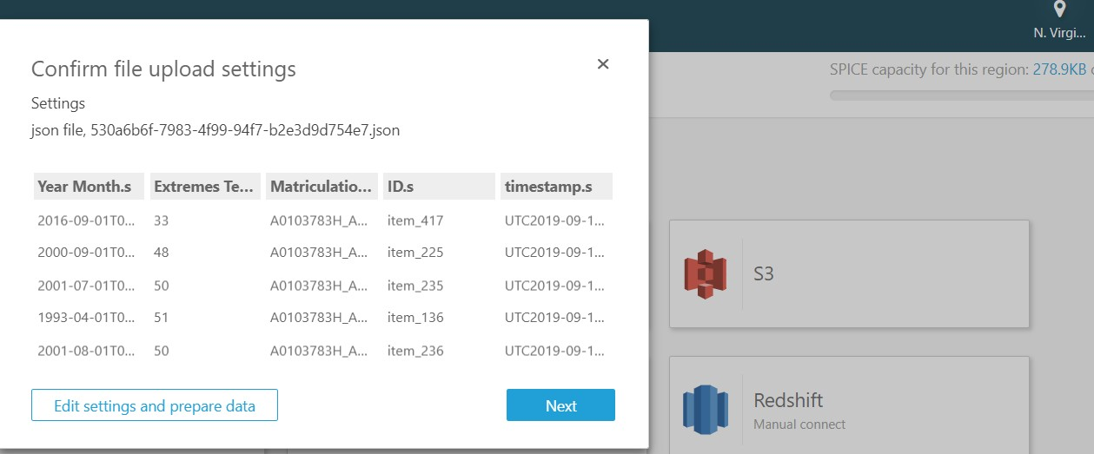

### Download data from S3 Bucket

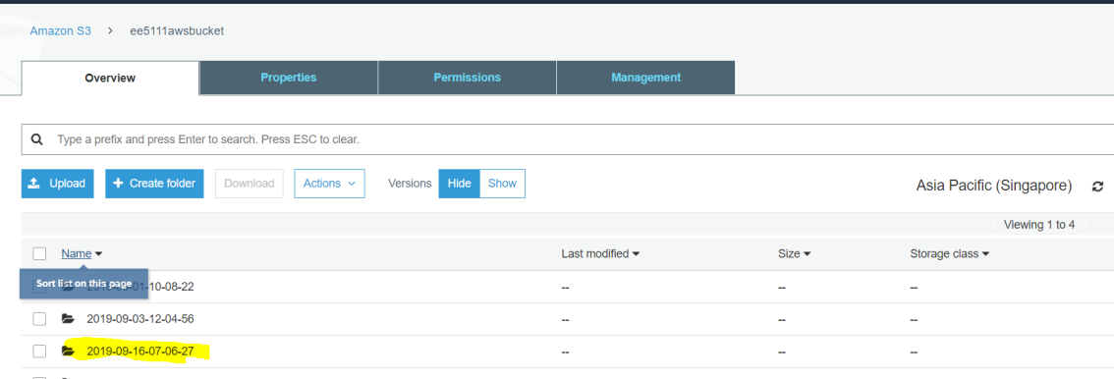

|  |  |
| --- | --- |
|  | |
|  |  |
|  | |
|  | |
|  | |

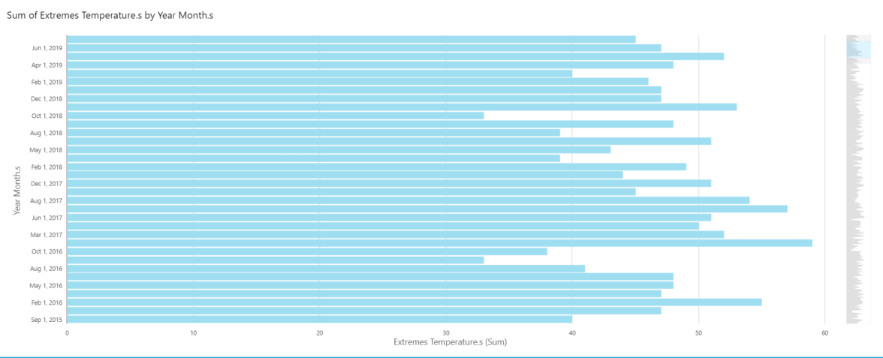

### Using QucikSight to visualize the data from desktop.

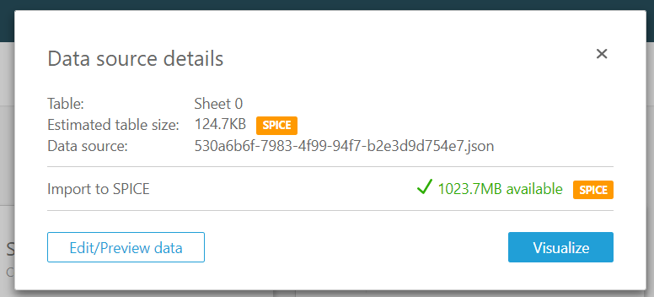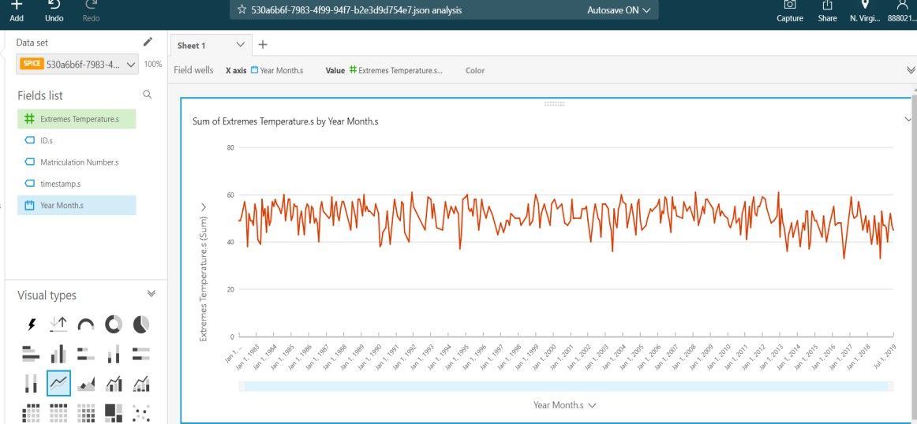

Sum of Extremes Temperature.s by Extremes Temperature.s and Year Month.s

SHOWING TOP 50 INYEAR MONTH.S AND BOTTOM 221N EXTREMES TEMPERATURE.S

46

47

48

49

50

51

52

53

54

55

57

59

N-- N

•

N N N N N N

i'i N N N-- N

"' "' "' "'

"' -

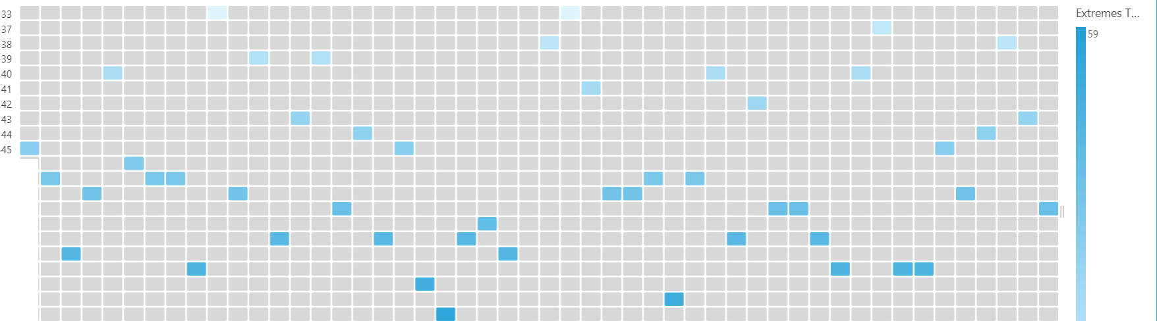

- • ;g - -

Year Month.s 33